EMU PREP SCHOOL STUDENT ACTIVITY CALENDER 2025-2026 FALL
We have some great activities planned for you this semester. You can get more information about each activity from posters around the school or from the SAT Office. Please be sure to sign up for these activities at the SAT Office.
Please note: All activities are subject to change.
 | Monday | Tuesday | Wednesday | Thursday | Friday
13-17 Oct |  |  |  | Speaking Club  SSSC 14:30 (All Levels)  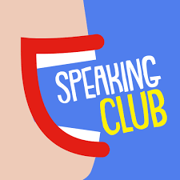 | Backgammon Tournament    13:00  Latin Dance  13:00  (Prep 01)  
20-24 Oct |   Seminar: Cultuıre Shoc k |   Chair Yoga |  | 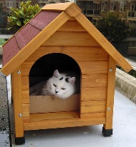  Visiting Animal Shelter 14:30  Speaking Club  SSSC 14:30 (All Levels)  Seminar: Effective Ways Of Studying  | Trip To Kapalı Maraş  13:00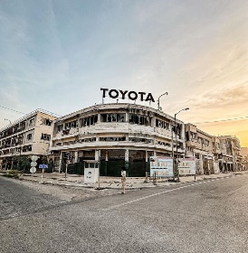  Latin Dance  13:00  (Prep 01)
 | Monday | Tuesday | Wednesday | Thursday | Friday
27-31 Oct |  |  |  | Speaking Club  SSSC 14:30 (All Levels) | Halloween  Latin Dance  13:00  (Prep 01)
3-7  Nov |   Seminar: Exam Anxiety | 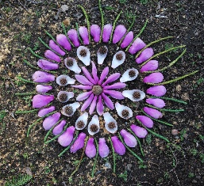  Upcycling: Nature Mandala |  | Speaking Club  SSSC 14:30 (All Levels) | Latin Dance  13:00  (Prep 01)
10-14 Nov |  |  |  | Speaking Club  SSSC 14:30 (All Levels) | Latin Dance  13:00  (Prep 01)
17-21 Nov |  |  |  | Speaking Club  SSSC 14:30 (All Levels) | 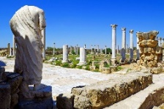  Trip To Salamis Ruins  Latin Dance  13:00  (Prep 01)
24-28 Nov |  |  |  | Speaking Club  SSSC 14:30 (All Levels) | Quiz Monster  (B1 + UB1)  Latin Dance  13:00  (Prep 01)
1-5 Dec |  |  |  | Speaking Club  SSSC 14:30 (All Levels) | Quiz Monster    (A1 + A2)  Latin Dance  13:00 (Prep 01)
8-12 Dec | Seminar: Psychological Wellbeing    Seminar: Stress Management |  | Visiting Elderly Home 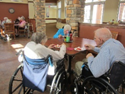 | Speaking Club  SSSC 14:30 (All Levels)  Upcycling: Christmas Tree | Latin Dance  13:00  (Prep 01)
Friday
Thursday
Wednesday
Tuesday
Monday

